**The extraordinary ways species control their own evolutionary fate**

**Natural selection isn't just something that happens to organisms, their activities also play a role, giving some species – including humans – a supercharged ability to evolve**

**By**[**Kevin Lala**](https://www.newscientist.com/author/kevin-lala/)

**4 December 2024**

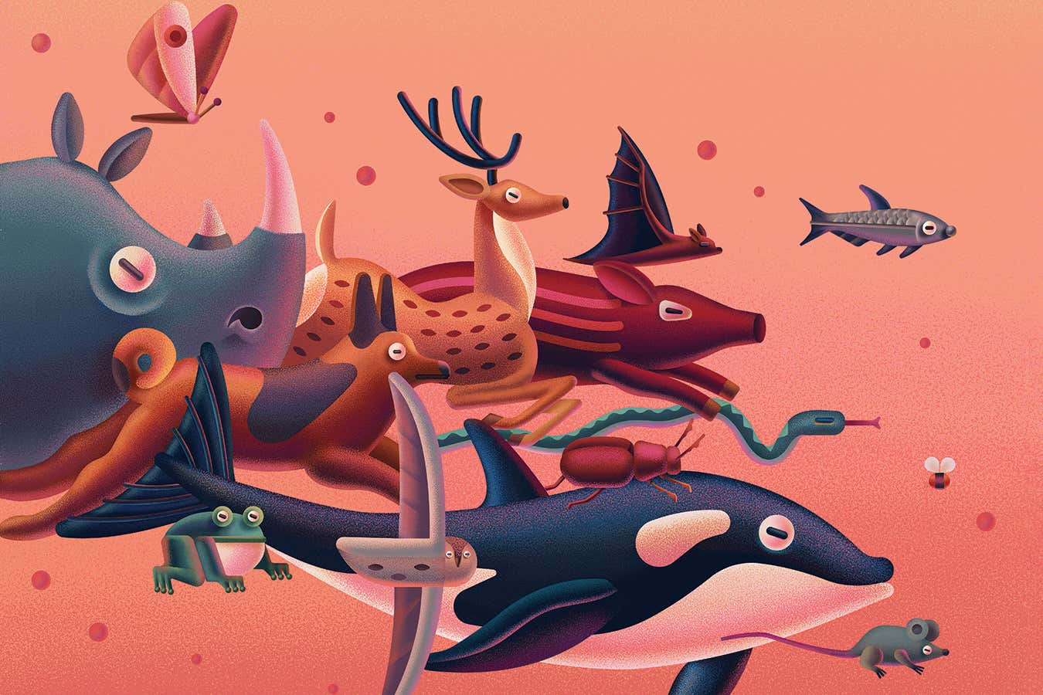

**Mary Maka**

Living in the desert is a challenge. But the Mojave desert woodrat has an ace to play: it can eat poison. This allows the cute little rodent to survive and thrive by feeding on toxic creosote bushes. Remarkably, it hasn’t evolved the genes required to do so. Instead, it eats the faeces of other woodrats and thereby inherits detoxifying bacteria that take up residence in its gut.

The desert woodrat is an example of how the things organisms do can affect their evolution. And it is far from a one-off: in recent years, it has become clear that many organisms influence their own evolution by creating non-genetic traits that can become subject to natural selection. This challenges traditional Darwinian thinking, which sees evolution as a process rooted in random genetic mutation. But that’s not all. These non-genetic ways of adapting may also help explain another puzzling aspect of evolution – evolvability, or why some organisms have a greater capacity to evolve than others.

**[Read more](https://www.newscientist.com/article/mg24732940-800-a-radical-new-theory-rewrites-the-story-of-how-life-on-earth-began/)**

**[A radical new theory rewrites the story of how life on Earth began](https://www.newscientist.com/article/mg24732940-800-a-radical-new-theory-rewrites-the-story-of-how-life-on-earth-began/)**

I am one of a growing group of evolutionary biologists who believe that non-genetic inheritance plays a vital role in evolvability. This has practical implications. Faced with climate change, species must adapt fast or go extinct, and evidence is mounting that extragenetic adaptations, such as those found in the desert woodrat, can rescue organisms from the brink. The new thinking has implications for how we view our own evolution, too. Our complex culture makes the way humans evolve very different and far more rapid than the evolution of most other species. This unusual, supercharged evolvability gives us more control over our evolutionary future than we might think.

Historically, evolutionary biologists have assumed that since all organisms evolve through natural selection acting on their genes, they should all change at roughly the same rate per generation. Only in recent years has it become clear this isn’t the case – some species and some traits are more evolvable than others. Until now, research has [focused on genetic change](https://www.newscientist.com/article/mg20627661-400-evolvability-how-to-cash-in-on-the-genetic-lottery/), and [genes undoubtedly are part of the explanation](https://direct.mit.edu/books/oa-edited-volume/5602/EvolvabilityA-Unifying-Concept-in-Evolutionary). But emerging evidence indicates that extragenetic processes are important, too.

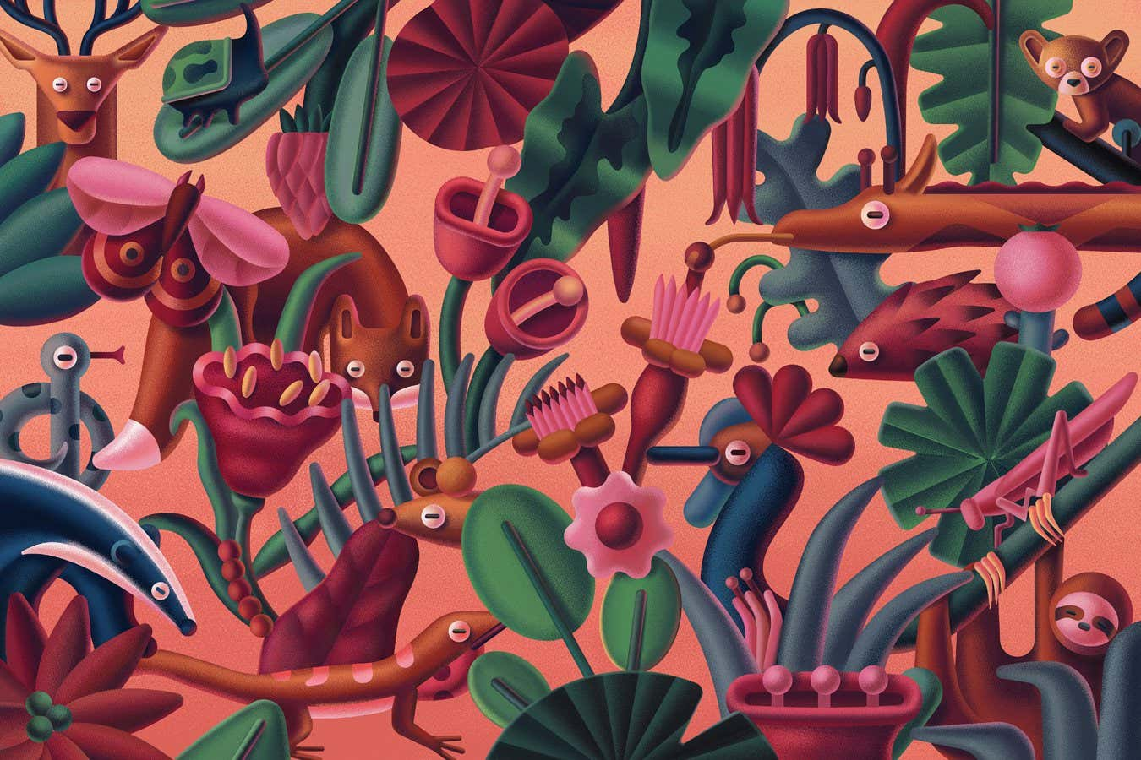

**Mary Maka**

This idea features in a new book that I co-authored – [*Evolution Evolving*](https://www.evolutionevolving.org/)*: The developmental origins of adaptation and biodiversity*. A variety of processes are involved, but here I will focus on three of the most important and intriguing: epigenetics, symbiotic inheritance and culture. These phenomena aren’t just analogous to biological evolution: they *are* biological evolution. They allow organisms to invade new environments, cope with change and stress, evolve new phenotypes and resist extinction until adaptive genetic mutations appear.

**Epigenetic evolution**

Consider, first, [epigenetic inheritance](https://www.newscientist.com/definition/epigenetics/). The DNA in each cell isn’t bare, it is clothed in a variety of chemically attached molecules that affect whether or not nearby genes will be expressed. These modifications are epigenetic; they don’t involve changes in the DNA sequence but nonetheless influence gene activity. The best-studied example is methylation, the addition of a methyl chemical group to one of DNA’s nucleotide bases. This acts as a physical barrier, suppressing a gene’s activity. Conversely, removal of the attachment allows a gene to be expressed. When a methyl group blocks the activity of a regulatory gene, the genes under its control can be expressed or suppressed more readily.

Some epigenetic attachments and detachments are specified by the DNA sequence itself, others occur at random, still others happen in response to environmental factors, including diet and pollution. When cells divide, these attachments are copied, which is what allows groups of cells, such as tissues, to maintain distinct patterns of gene expression from one another, even though they share the same DNA. In mammals, almost all epigenetic modifications are erased during the production of sex cells or in the embryo. In some animals, however, they are more commonly transmitted across generations. And in plants too, environmentally induced epigenetic changes are frequently inherited.

[[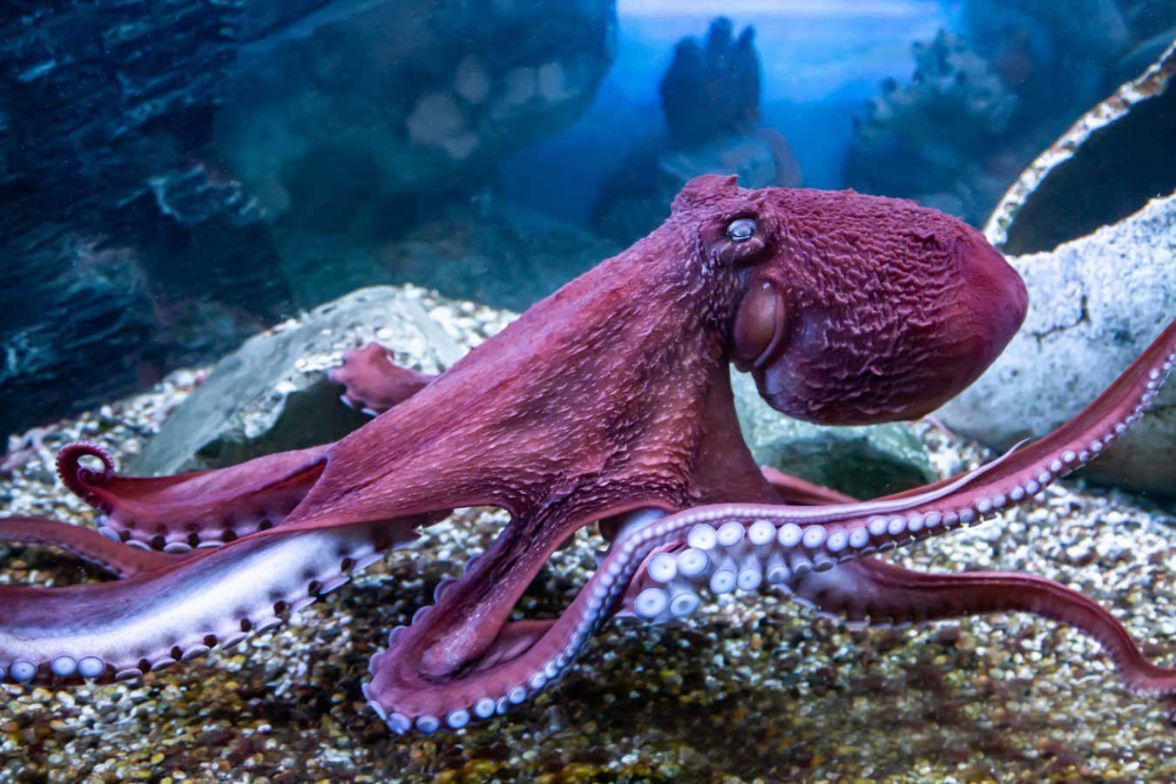](https://www.newscientist.com/article/2440012-are-animals-conscious-were-finally-realising-that-many-species-are/)](https://www.newscientist.com/article/2440012-are-animals-conscious-were-finally-realising-that-many-species-are/)

**[Are animals conscious? We’re finally realising that many species are](https://www.newscientist.com/article/2440012-are-animals-conscious-were-finally-realising-that-many-species-are/)**

**[Science is at last confirming what many people have long suspected – that mammals, birds and perhaps some invertebrates have elements of consciousness](https://www.newscientist.com/article/2440012-are-animals-conscious-were-finally-realising-that-many-species-are/)**

Until recently, the idea that epigenetic variation is subject to natural selection was controversial. In 2018, publication of an experiment in thale cress (*Arabidopsis thaliana*) – the lab rat of plants – changed that. [Marc Schmid](https://scholar.google.ch/citations?user=wTNz6u4AAAAJ&hl=de), then at the University of Zurich, Switzerland, and his colleagues grew these plants in an environment that simulated a frequently disturbed, fragmented habitat and then selected only those that successfully dispersed to new locations, using these to form the next generation. Within just five generations, the population had evolved adaptations in flowering time and root density, but with no detectable change in gene frequencies. Instead, the adaptations had occurred through the [natural selection of epigenetic variation](https://www.nature.com/articles/s41467-018-06932-5).

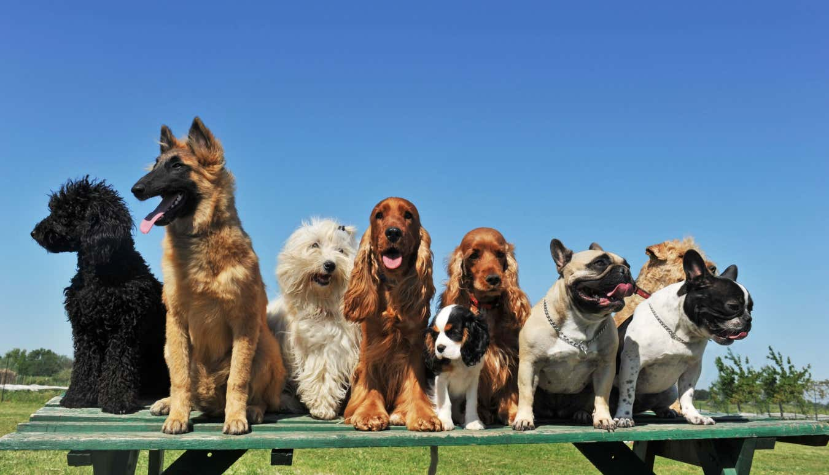

**Dogs seem to have adapted to a human-like diet by first acquiring symbiotic microbes that can digest starch**

**Alamy Stock Photo**

Research published the following year backed up the idea that epigenetics can lead to adaptive evolution. [Dragan Stajic](https://www.fiwi.vetsuisse.unibe.ch/about_us/people___invisible/dr_sc_nat_stajic_dragan/index_eng.html), then at the Gulbenkian Institute of Science in Oeiras, Portugal, and his colleagues investigated the evolutionary adaptation of yeast to a toxic chemical. Their yeast populations were genetically identical but engineered to have different levels of epigenetic inheritance. The majority of those with low or no epigenetic inheritance went extinct, whereas other populations were able to survive and grow as a result of [short-term adaptation through epigenetic change](https://www.nature.com/articles/s41559-018-0781-2). This established an evolutionary beachhead, creating time for slower genetic adaptation to take its course.

**A buffer against extinction**

This has implications for many organisms threatened by global warming. In the face of rapid environmental change, strong selection can erode a population’s genetic variation, making evolutionary rescue through genetics even more unlikely. But epigenetic adaptation creates variation in characteristics, increasing the likelihood that some fraction of the population will persist long enough to adapt genetically. What’s more, the fact that some epigenetic variation is environmentally induced means that, unlike genetic mutation, it can appear suddenly in multiple individuals. This makes potentially adaptive variants less vulnerable to loss through random processes. In this way, epigenetics can [buffer a population against extinction](https://academic.oup.com/eep/article/2/1/dvv014/2464778?login=false).

Let’s turn now to symbiotic inheritance. The burgeoning interest in [microbiomes has made it clear that animals are teeming with microbes](https://www.newscientist.com/article/2395371-where-does-your-gut-microbiome-really-come-from-and-does-it-matter/). Such symbiotic relationships are common throughout nature, and the Mojave desert woodrat [provides a clear example](https://onlinelibrary.wiley.com/doi/10.1111/ele.12329) of how they can influence evolvability.

One thing that makes symbiotic inheritance so powerful is that it needn’t be passed from parent to offspring – it can spread among unrelated individuals and even occur across species. For example, plants that grow on geothermal soils are commonly associated with a heat-tolerant mould called *Curvularia*, and experiments show that [exposure to this mould increases the survival](https://www.science.org/doi/10.1126/science.1078055) of other species of plants when they are subjected to heat stress. Similarly, salt-tolerant fungi can enter symbiotic relationships that help non-adapted plants survive salty conditions. More problematically – at least from a human perspective – various insects have acquired [pesticide resistance from a pesticide-degrading bacterium](https://www.pnas.org/doi/10.1073/pnas.1200231109). And the red turpentine beetle recently became a pest when it acquired a fungal symbiont that allowed it to infest live trees. [Millions of trees in China have perished as a consequence](https://link.springer.com/article/10.1007/s10531-004-0697-9).

**From the origin of life, organisms channelled and directed their own evolution**

Dogs have also benefited from symbiotic inheritance. Their wild ancestors were carnivores, but during the course of domestication, dogs adapted to eat a more starchy diet associated with farming. Today, [like us](https://www.science.org/content/article/how-humans-evolved-starch-digesting-superpower-long-farming), they have extra copies of two genes, *AMY1* and *AMY2*, that aid in the digestion of starch by producing enzymes secreted in saliva and the pancreas. Ancient DNA extracted from 3500-year-old fossil dogs and their faeces, however, reveals that while these animals [lacked this genetic adaptation](https://www.cell.com/iscience/fulltext/S2589-0042(21)00784-7?_returnURL=https%3A%2F%2Flinkinghub.elsevier.com%2Fretrieve%2Fpii%2FS2589004221007847%3Fshowall%3Dtrue), they did possess symbiotic bacteria that broke down starch in their bodies. Seemingly, dogs adapted to their novel diet in two stages, first through bacterial symbionts, and only thousands of years later through genetic change.

[[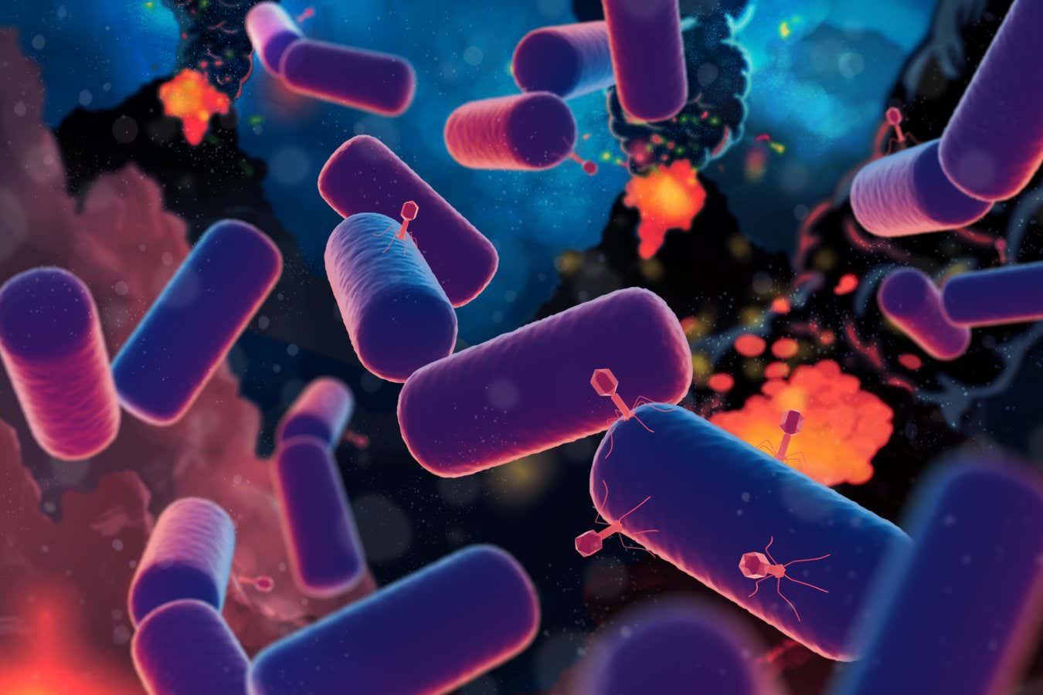](https://www.newscientist.com/article/2439385-last-common-ancestor-of-all-life-emerged-far-earlier-than-thought/)](https://www.newscientist.com/article/2439385-last-common-ancestor-of-all-life-emerged-far-earlier-than-thought/)

**[Last common ancestor of all life emerged far earlier than thought](https://www.newscientist.com/article/2439385-last-common-ancestor-of-all-life-emerged-far-earlier-than-thought/)**

**[All life on Earth can trace its origin to LUCA, the last universal common ancestor – and now it seems this organism may have lived a few hundred million years after the planet formed](https://www.newscientist.com/article/2439385-last-common-ancestor-of-all-life-emerged-far-earlier-than-thought/)**

Other examples of symbiotic inheritance are found in humans. Japanese people, but not Westerners, can digest the jelly-like substance agar because they have a bacterium in their gut that contains a gene coding for the enzyme agarase. They are thought to have [acquired this bacterium through eating seaweed](https://www.nature.com/articles/nature08937). Similarly, some human populations can digest dairy products despite lacking the gene variant for adult lactose absorption that [emerged among dairy farmers](https://www.newscientist.com/article/dn27938-everything-you-need-to-know-about-lactose-intolerance/) around 7000 years ago. In this case, their [agricultural activities have exposed them to bacteria](https://www.mdpi.com/2304-8158/11/15/2276) that do the job when ingested. Indeed, the human appendix is testament to the vital role that symbionts play in our survival. Long regarded as a vestigial organ with no current function, it is now thought to act as [a repository for beneficial](https://www.newscientist.com/article/mg19826562-100-vestigial-organs-remnants-of-evolution/) gut microbes that can recolonise the intestine after bouts of stomach disease and infection

.

**Highly cultured animals**

What really makes us so extraordinarily adaptable, however, is culture. It is well-established that human culture can generate complex adaptations that are subject to selection – a classic example being the aforementioned evolution of agriculture. But things get more interesting with the recognition that [many other animals have culture too](https://www.newscientist.com/article/mg20827871-500-culture-club-all-species-welcome/). In fact, in the past half century, scientific investigations have shown it to be surprisingly common. Countless species transmit learned knowledge from one group member to another and down the generations through imitation and other forms of social learning. Such cultural inheritance includes dietary information, feeding techniques, songs and calls, predator recognition and avoidance methods, and learned migratory pathways.

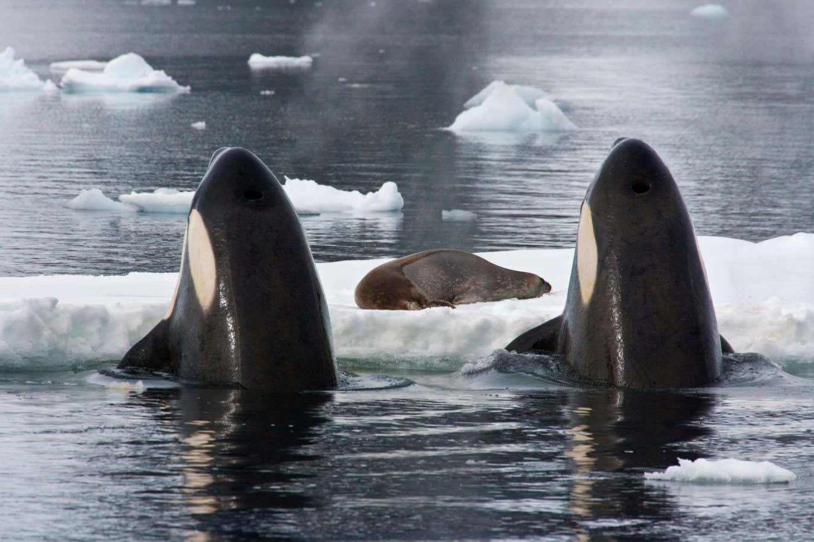

**Orca evolution is driven partly by culture, such as hunting behaviour**

**Doug Allan/Nature Picture Library/Alamy**

The influence of culture on evolution is seen clearly in killer whales. Some populations of orcas have learned to make waves to dislodge seals from ice floes, others lunge onto beaches to pick off prey. These adaptive differences in diet and hunting technique aren’t due to genetic variation, they are the product of behavioural innovation and social learning. Nonetheless, such cultural differences in hunting have biological impacts. Despite often living side by side, groups of whales with different foraging habits [are reproductively isolated](https://onlinelibrary.wiley.com/doi/10.1111/mec.12929). As a result, they have diverged genetically and exhibit morphological and physiological adaptations such as population-specific digestive enzymes and face shape.

Like epigenetic adaptation, cultural adaptation has important implications for evolutionary rescue from extinction because culture can change more rapidly than genes. This is relevant to conservation strategies because it implies that the first response of many endangered animals is likely to be cultural rather than genetic. It also means that animals with culture may have a greater capacity to adapt to climate change.

The upshot of all this is that natural selection isn’t something that just happens to organisms: their activities and behaviours contribute to how it happens and whether it happens at all. Culture, symbiosis and epigenetics all promote evolvability, and they aren’t the only extragenetic mechanisms at play (see [“Enhanced adaptability”](https://www.newscientist.com/article/mg26435201-500-the-extraordinary-ways-species-control-their-own-evolutionary-fate/?utm_source=nsnew&utm_medium=email&utm_campaign=nsnew_051224&utm_term=Newsletter%20NSNEW_Weekly#DeepDive-1), below). That means a conception of how organisms work should be central to our understanding of evolution. This adds a whole new dimension to the evolutionary process because the things organisms do that influence their evolution have themselves evolved through natural selection – making the Darwinian evolutionary algorithm cyclical. From the origin of life, through continual interactive cycles of causation, organisms have channelled and directed their own evolution, and evolution has sculpted them in turn.

**[Read more](https://www.newscientist.com/article/2457910-orcas-have-begun-wearing-salmon-hats-again-and-we-may-soon-know-why/)**

**[Orcas have begun wearing salmon hats again – and we may soon know why](https://www.newscientist.com/article/2457910-orcas-have-begun-wearing-salmon-hats-again-and-we-may-soon-know-why/)**

**Rethinking human evolution**

This new perspective on evolvability has big implications for how we regard our own evolution. Historically – perhaps to distance themselves from creationists and mystics – evolutionary biologists have maintained that humans evolve in a manner no different from fruit flies or yeast, that it all comes down to the natural selection of chance mutations. This simple, bleak story lacks credence to some people, which might help explain why there is resistance to evolutionary theory. Instead, in the light of these new findings, we should be emphasising that human evolution is actually very unusual, because evolvability depends on what organisms do, and our activities are quite distinct from those of other species.

[[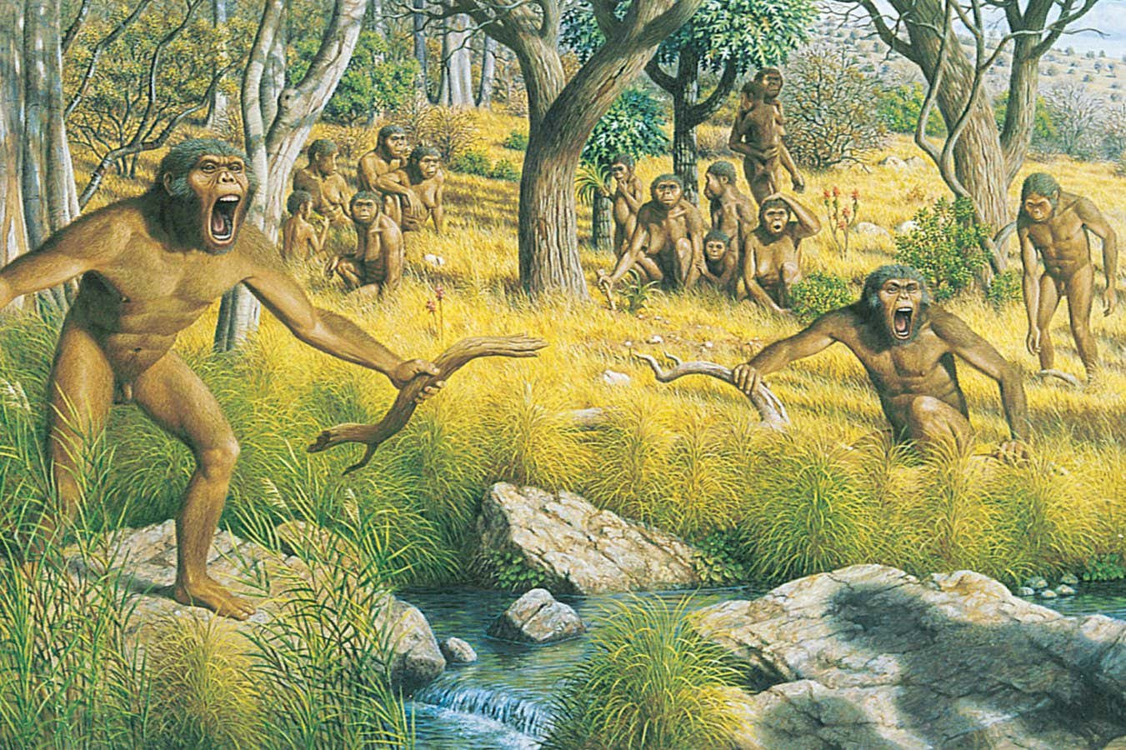](https://www.newscientist.com/article/2447242-when-did-humans-leave-the-trees-for-the-savannah-or-did-they-at-all/)](https://www.newscientist.com/article/2447242-when-did-humans-leave-the-trees-for-the-savannah-or-did-they-at-all/)

**[When did humans leave the trees for the savannah – or did they at all?](https://www.newscientist.com/article/2447242-when-did-humans-leave-the-trees-for-the-savannah-or-did-they-at-all/)**

**[Ancient humans are said to have evolved to leave the trees, where our primate ancestors lived, in favour of open grassy savannahs – but we may have this idea wrong](https://www.newscientist.com/article/2447242-when-did-humans-leave-the-trees-for-the-savannah-or-did-they-at-all/)**

Human culture is off the scale compared with any other animal when it comes to symbolism, technology and informational content. The significance of this becomes clear once we recognise cultural change for what it really is – not so much an analogue of biological evolution, but rather a key aspect of rapid-response evolutionary adaptation. This means that we are far more evolvable than most other species – and we control our own evolution to a much greater extent. But our choices don’t just affect us, they have wide-reaching impacts across the environment. This gives us enormous power over the future evolution of all life on Earth – for good or ill.

**Enhanced adaptability**

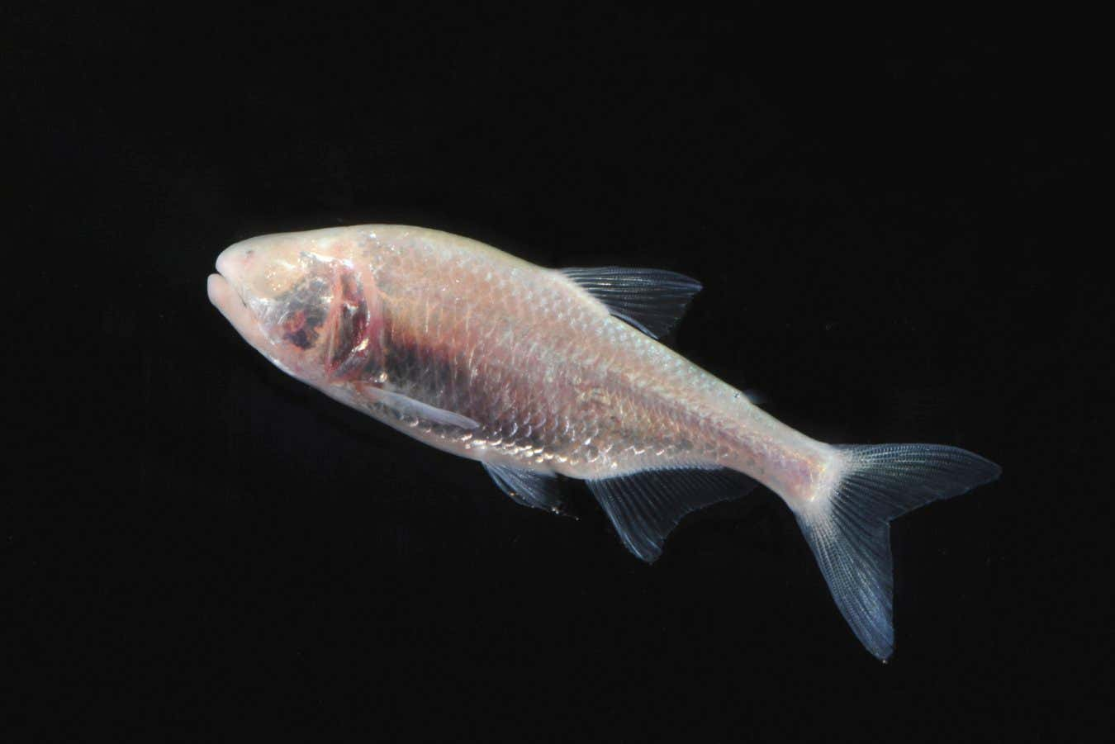

**Barry Mansell/naturepl.com**

**An organism’s capacity to evolve, known as evolvability, can be influenced by non-genetic phenomena such as symbioses and culture (see main story). But they aren’t the only non-genetic ways to be adaptable.**

**Developmental plasticity, for example, is a kind of variation caused by environmental factors influencing the way that an organism develops. Although initially there is no change in the genes,**[**plasticity can increase the ability to evolve**](https://www.newscientist.com/article/mg22530040-300-adapt-first-mutate-later-is-evolution-out-of-order/)**.**

**Take the Mexican blind cavefish (pictured above). At least 30 cavefish populations are known, mostly eyeless and with reduced pigmentation, and sometimes also with characteristic bone structure, fat storage and foraging behaviour. Other populations of these fish live in rivers and lack these traits. But, when reared in the dark, they come to**[**resemble their cave-dwelling cousins**](https://elifesciences.org/articles/51830)**because developmental plasticity allows these same traits to emerge.**

**Such plasticity doesn’t just help organisms cope with novel challenges, it also**[**helps them evolve**](https://onlinelibrary.wiley.com/doi/10.1111/ede.12374)**by packaging together a suite of adaptive traits. Natural selection can only work with the available variation, so evolution becomes channelled along these self-generated axes of linked traits.**

**Another way organisms can increase their evolvability is by modifying their environment, a process known as niche construction. By building a nest or burrow, for example, animals control key aspects of their environment, such as temperature. If their offspring’s development is sensitive to these conditions, plastic traits can coevolve with the niche-constructing traits. And because niche construction tends to link adaptive traits together, it too influences both evolvability and the direction of evolution.**